Parents,
The district will receive STAAR Confidential Student Reports at the end of June, and they will be mailed home as soon as possible, but until then you can view your student’s STAAR results online at:
texasassessment.com
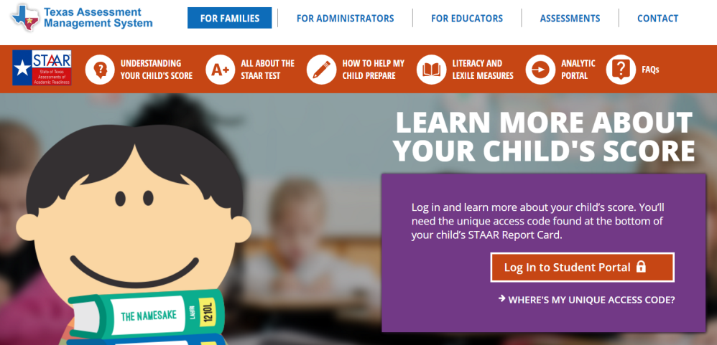
On this screen, click on “Log in to Student Portal”
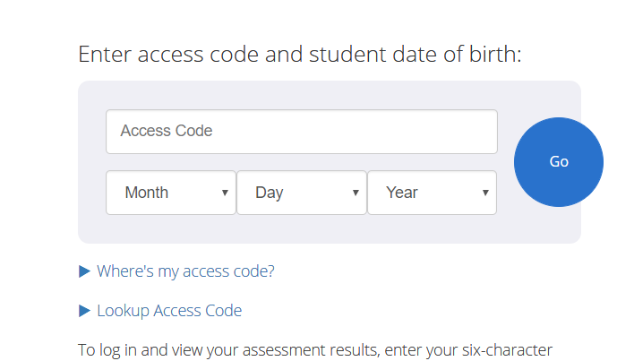
You will not have an access code at this time, so click on “Lookup Access Code.”
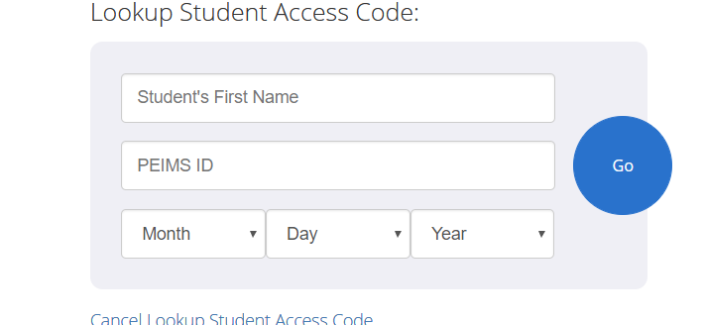
Enter your student’s First Name, Social Security Number and Birthdate and you will be able to view your student’s entire testing history. Click on each test to see detailed results. If your student is in the “Approaches” level, he/she met the requirements for passing the test.

