February Issue | McKinley Eagle News
Quote of the Month  Parent Resources | “The function of education is to teach one to think intensively and to think critically. Intelligence plus character – that is the goal of true education.”  Martin Luther King Jr.  Winter 2017 NWEA MAP Data  Mathematics  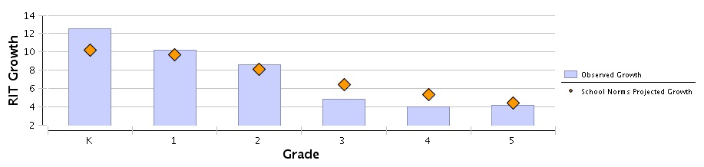  A RIT score measures a student's level of achievement in a particular subject. If a student has a particular RIT score, this means that the student is about 50% likely to correctly answer an item calibrated at that RIT level, and therefore topics at this RIT level are likely to be topics the student is ready to learn. The growth in RIT points made between the two terms in the Growth Comparison Period.  Winter 2017 NWEA MAP Data  Reading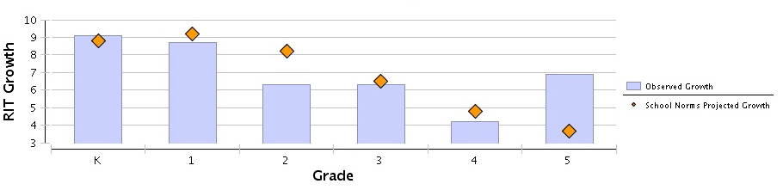
A RIT score measures a student's level of achievement in a particular subject. If a student has a particular RIT score, this means that the student is about 50% likely to correctly answer an item calibrated at that RIT level, and therefore topics at this RIT level are likely to be topics the student is ready to learn. The growth in RIT points made between the two terms in the Growth Comparison Period.

Information to encourage strong parent engagement
The PARCC assessments serve as an “educational GPS system,” assessing students’ current performance, and pointing the way to what students need to learn to be ready for the next grade level and, by high school graduation, for college and/or a career.
The PARCC assessments are designed to give schools and teachers more information to improve instruction. Moreover, PARCC is designed to let parents know how their child is progressing academically. This more detailed information can lead to strong engagement between parents and teachers.
Please note that your child’s score report is not available here. Please contact your child’s school or local school district to find out about your child’s score report.
https://parcc-assessment.org/parent-resources/

